**HCI Text to Keyword**

Below is a step by step guide on how to run the HCI Text to Keyword

**Step 1: Download the node.js installer**

For the first step you will be installing the node.js installer, you first will need to download the installer. You will be able to find the installer at the official node.js download page [here](https://nodejs.org/en/download/).

**Step 2: Running the Node.js Installer**

Now that you’ve got the installer there are few steps in the installer to go through. There isn’t much to modify but here are the steps to navigate through the installer.

* Welcome to node.js Setup wizard – Select Next
* End-user License agreement – Check the I accept and select next
* Destination Folder- Choose a different folder if you want and select next
* Custom Setup- You can skip this as well, and select next
* Ready to install Node.js – Select Install, this will require admin privileges if running on University computers
* Install of node.js- this should take awhile but as soon as your done select Finish!

**Step 3: Installing npm live-server**

Now that node.js has been installed, you need to install live-server.

For this we opened the Windows Powershell and ran the command “npm install -g live-server” as seen below.

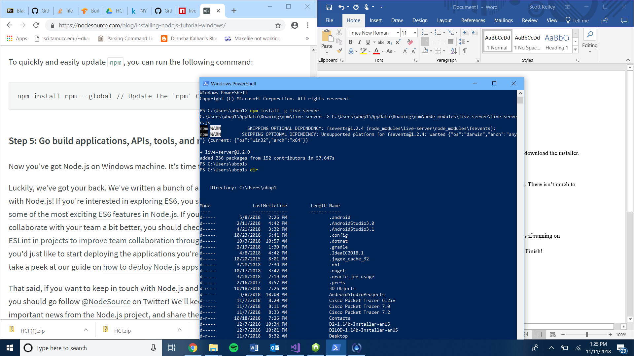

Once live server is installed the HCI Text to Keyword setup is basically done! Now navigate to the correct directory in Windows Powershell where the HCI Text to Keyword zip was extracted. Once in the correct directory run the application with the “live-server” command as seen below.

